

The University of Azad Jammu and Kashmir, Muzaffarabad

Name Kamal Ali Akmal
Course Name | Software Designs and Architectures
Submitted to | Engr. Daniyal Nazir
Semester | 3rd
Session | 2024-2028
Roll No | 2024-SE-38
Lab No | 12
Submission date | 2 February 2026

Pipe-and-Filter Architecture for Text Processing
Objective
The objective of this task is to understand the Pipe-and-Filter Architecture and apply it to a text processing system that generates a summary from a text file.

Introduction to Pipe-and-Filter Architecture
Pipe-and-Filter Architecture is a software design pattern in which a system is divided into independent processing units called filters.
Each filter performs a specific task and passes its output to the next filter through pipes.
- Filters → Perform processing
- Pipes → Transfer data between filters
Each filter:
- Is independent
- Does not know about other filters
- Only processes input and produce output
This architecture is widely used in:
- Compilers
- Text processing systems
- Data processing pipelines

Scenario Overview
The system processes a text file to generate a summary.
The text flows through a series of filters, where each filter performs a specific operation on the data.

Task 1: Identification of Filters
The following filters are used in the text processing system:
1. Input Reader Filter
Purpose
Reads raw text data from a text file.
Responsibilities
- Open the text file
- Read the content line by line
- Pass raw text to the next filter
Input
- Text file
Output
- Raw text data
2. Text Cleaning Filter
Purpose
Cleans and preprocesses the text.
Responsibilities
- Remove punctuation
- Remove special characters
- Convert text to lowercase
- Remove unnecessary spaces
Input
- Raw text data
Output
- Cleaned text
3. Word Counting Filter
Purpose
Analyzes the cleaned text and counts words.
Responsibilities
- Split text into words
- Count frequency of each word
- Identify important or frequently used words
Input
- Cleaned text
Output
- Word count data (frequency list)
4. Summary Generator Filter
Purpose
Generates a summary from the processed data.
Responsibilities
- Select important words or sentences
- Reduce text length
- Generate a concise summary
Input
- Word count data
Output
- Final text summary
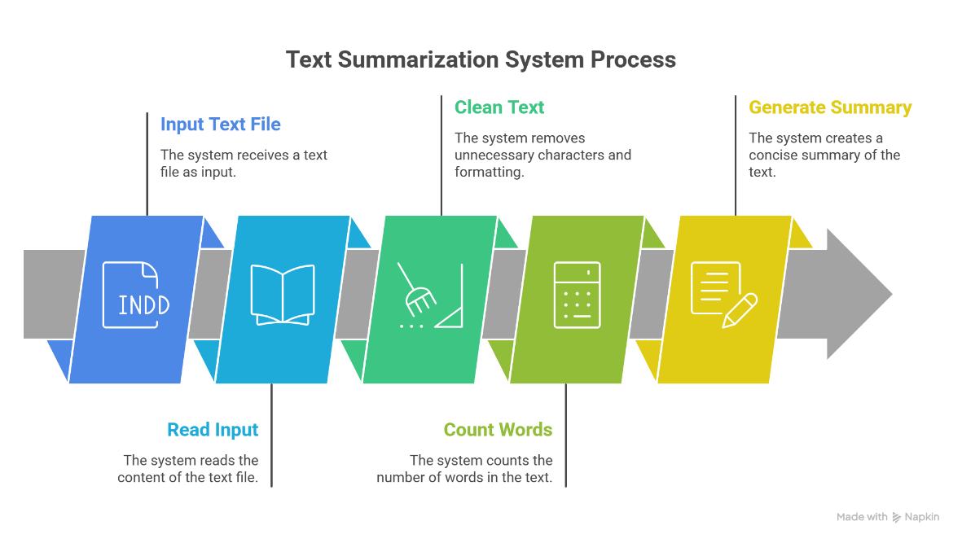

Task 2: Identification of Pipes
Pipes are responsible for data transfer between filters.
Each pipe carries the output of one filter as input to the next filter.
Pipes in the System

Pipe Name | Connects Filters | Data Passed
Pipe 1 | Input Reader → Text Cleaning | Raw text
Pipe 2 | Text Cleaning → Word Counting | Cleaned text
Pipe 3 | Word Counting → Summary Generator | Word frequency data
Advantages of Pipe-and-Filter Architecture
- Easy to understand and maintain
- Filters can be reused
- Filters can be modified independently
- Supports parallel processing

Task 3: UML component diagram
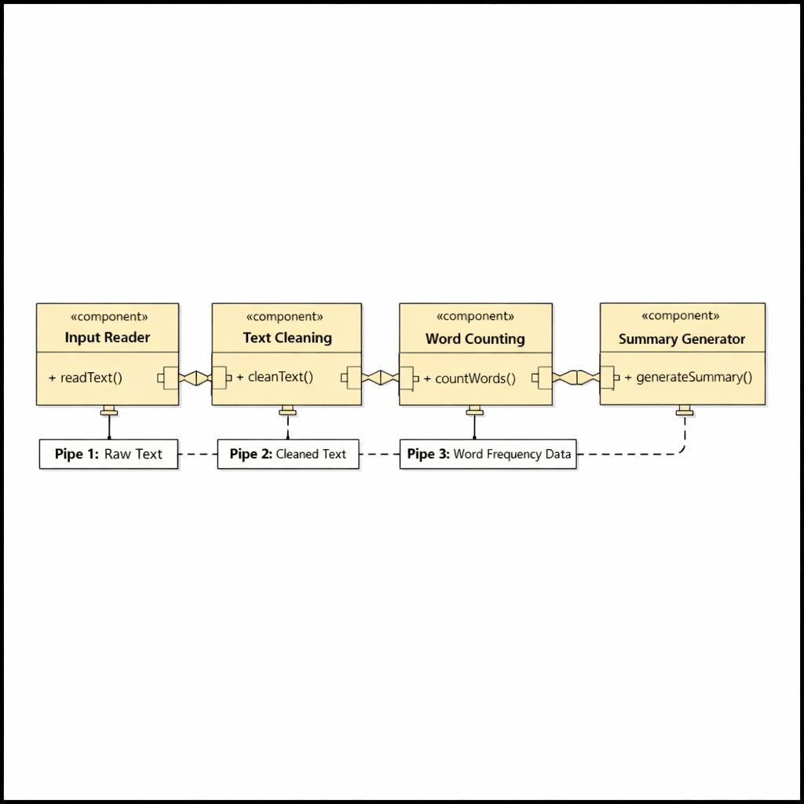
Task 4: Explain How Data Flows Through the System
In the Pipe-and-Filter architecture, data flows through the system in a sequential and linear manner. The output of one filter becomes the input of the next filter through pipes.
First, the Input Reader filter reads the raw text data from the text file and sends it through a pipe to the next filter. This raw text is not modified at this stage; it is only extracted and forwarded.
Next, the Text Cleaning filter receives the raw text and processes it by removing punctuation, special characters, and unnecessary spaces. The cleaned text is then passed through another pipe to the Word Counting filter.
The Word Counting filter analyzes the cleaned text and counts the frequency of words. It identifies important or frequently occurring words and sends this word frequency data through a pipe to the Summary Generator filter.
Finally, the Summary Generator filter uses the received data to create a concise summary of the original text. The final summarized output is produced at the end of the pipeline.
This flow ensures that each filter performs a specific task independently, making the system modular, efficient, and easy to maintain.

